Font Research

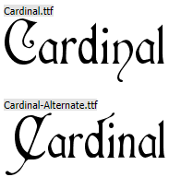

**Font Name:** Cardinal

**Link:** <https://www.dafont.com/cardinal.font>

**Feedback:** Pretty easy to read and fits medieval theme. Possibly a bit squashed together, but would save space in text boxes.

**Recommended:** sixth preference

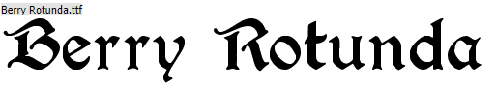

**Font Name:** Berry Rotunda

**Link:** <https://www.dafont.com/berry-rotunda.font>

**Feedback:** Ok readability, perhaps a bit bulky and would consume a lot of space in text boxes, but fits theme.

**Recommended:** No

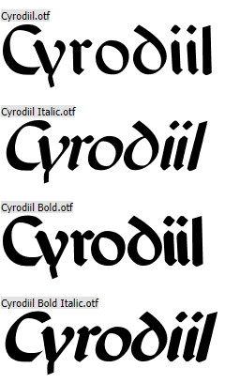

**Font Name:** Cyrodiil

**Link:** <https://www.dafont.com/cyrodiil.font>

**Feedback:** clean and easy to read, a good size and spacing between letters is good.

**Recommended:** first preference

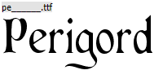

**Font Name:** Perigord

**Link:** <https://www.dafont.com/perigord.font>

**Feedback:** perhaps a little thin but easy to read, may be difficult on mobile as some letters look incomplete.

**Recommended:** fifth preference

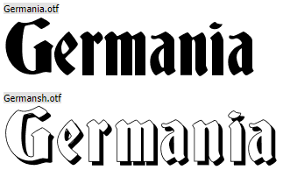

**Font Name:** Germania

**Link:** <https://www.dafont.com/germania.font>

**Feedback:** fits theme really well but too chunky and bold to be usable on mobile

**Recommended:** No

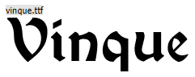

**Font Name:** Vinque

**Link:** <https://www.dafont.com/vinque.font>

**Feedback:** fits theme but some letters look confusing, otherwise quite easy to read. Not too chunky for mobile

**Recommended:** fourth preference

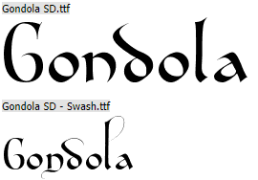

**Font Name:** Gondola SD

**Link:** <https://www.dafont.com/gondola-sd.font>

**Feedback:** too stylised to work well on mobile and some letters look odd, but can read it relatively well

**Recommended:** No

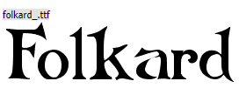

**Font Name:** Folkard

**Link:** <https://www.dafont.com/folkard.font>

**Feedback:** fits theme but possibly too big for mobile as its quite bold.

**Recommended:** second preference

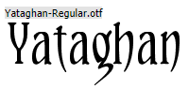

**Font Name:** Yataghan

**Link:** <https://www.dafont.com/yataghan.font>

**Feedback:** too thin to work well and would be difficult to read on mobile

**Recommended:** No

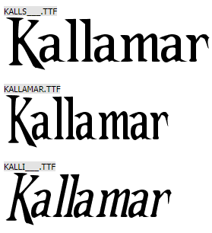

**Font Name:** Kallamar

**Link:** <https://www.dafont.com/kallamar.font>

**Feedback:** decent size, with a clear difference between capital and lower case. Just about fits theme but readable.

**Recommended:** third preference